Pew sheet & Newsletter for West Peckham & Mereworth Churches

Sunday 24th September –16th after Trinity
Readings: Jonah 3: 10-4:1-11, Matthew 20:1-16

10:00 –HC at St John the Baptist
11:30 – Sunday45 at St Dunstan's
17:00 – Refresh service at St Lawrence

Wednesday 27th September
10:30 – "Last Wednesday of the month” coffee and chat at St Lawrence

Sunday 1st October – 17th after Trinity- Harvest Festival
Readings: 2 Corinthians 9:6-15, Luke 17:11-19

10:00 – HC BCP at St Lawrence
10:00 – Harvest Praise service at St John the Baptist
11:30 – Harvest Service at St Dunstan's
17:00 – Refresh service at St Lawrence

Wednesday 4th October
10:00 – HC benefice service at St Lawrence followed by tea and chat.

News/upcoming dates for your diary

The Big Knit 2023 - The Diocese of Rochester is pleased to support Making Miracles' Big Knit 2023, which will be held in Rochester Cathedral on Saturday 28 October 2023 in conjunction with National Baby Loss Awareness Month.
The event runs from 9:00am until 12:00pm and participants are encouraged to knit or crochet squares, which will be made into blankets to be sold at fundraising events.

As refreshments will be provided, please email Sally Howells, the Chair of Making Miracles, on sally@makingmiracles.org.uk advising the names of anyone that is attending and more information can then be given. Full flyer also below.

------------------------------------------------------------------------------------------------------

Beginning in October there will be a Morning prayers service at St Lawrence Church on the 2nd and 4th Sunday at 08:30 – All welcome. This is in addition to other services.
------------------------------------------------------------------------------------------------------

There was also a misprint in the local Record magazine – There will be no Victoria Cross service on Sunday 24th September – This was a mis- print and we apologise for any confusion caused.

------------------------------------------------------------------------------------------------------

The 1st Confirmation class will be held on Saturday 7th October at 4pm at the Rectory. If you would like more information or to book onto this class, please email Gary: Gary.rev@outlook.com

------------------------------------------------------------------------------------------------------
Autum craft fair – Saturday 11th November – 11:30-14:00 – St Lawrence Church – For further information please email: mereworthpccsecretary@gmail.com

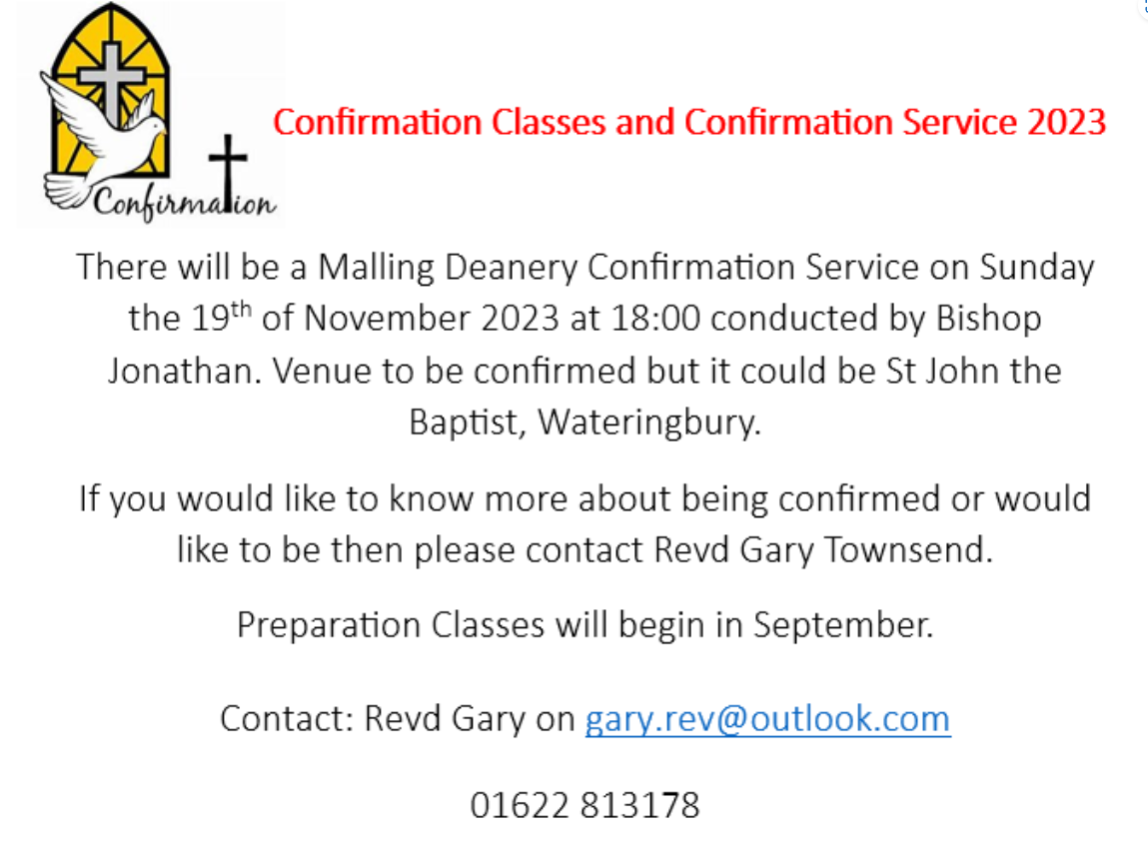

Do you shop online? If so please support your local churches below if you can


When shopping online please visit St Lawrence Church’ Easy Fundraising page https://www.easyfundraising.org.uk/causes/slcmereworth/ and click ‘support us’ and order via this site. You can also add Easy Fundraising to your desktop or mobile device so that it checks for you automatically when you shop. It costs you nothing but raises funds for St Lawrence Church

When shopping on line please visit ST John the Baptists easy fundraising page https://www.easyfundraising.org.uk/causes/wateringburychurch and click ‘support us’ and order via this site. It costs you nothing but raises funds for SJB.

Ukraine
Just a reminder that Mereworth church is open during daylight hours, and you are welcome to go in and use the side chapel at the back for prayer and lighting a candle for Ukraine.

If you would like to receive this Pew Sheet via email each week, please contact Clare at: office.mwwp@gmail.com . To contact Rev Gary regarding any of the services please email:
gary.rev@outlook.com

New website link : https://mwwpchurches.org/

